### **Project 12: 1602 LCD Display**

**Description**

[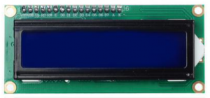](https://wiki.keyestudio.com/File:Ks008547.png)

With I2C communication module, this is a display module that can show 2 lines with 16 characters per line. It shows blue background and white word and connects to I2C interface of MCU, which highly save the MCU resources. On the back of LCD display, there is a blue potentiometer for adjusting the backlight. The communication address defaults to 0x27. The original 1602 LCD can start and run with 7 IO ports, but ours is built with Arduino IIC/I2C interface, saving 5 IO ports. Alternatively, the module comes with 4 positioning holes with a diameter of 3mm, which is convenient for you to fix on other devices.

Notice that when the screen gets brighter or darker, the characters will become more visible or less visible.

**Specifications:**

* I2C address: 0x27
* Backlight (blue, white)
* Power supply voltage: 5V
* Adjustable contrast
* GND: A pin that connects to ground
* VCC: A pin that connects to a +5V power supply
* SDA: A pin that connects to analog port A4 for IIC communication
* SCL: A pin that connects to analog port A5 for IIC communication

**Equipment：**

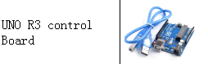

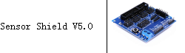

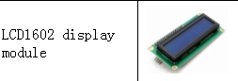

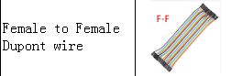

**Connection Diagram：**

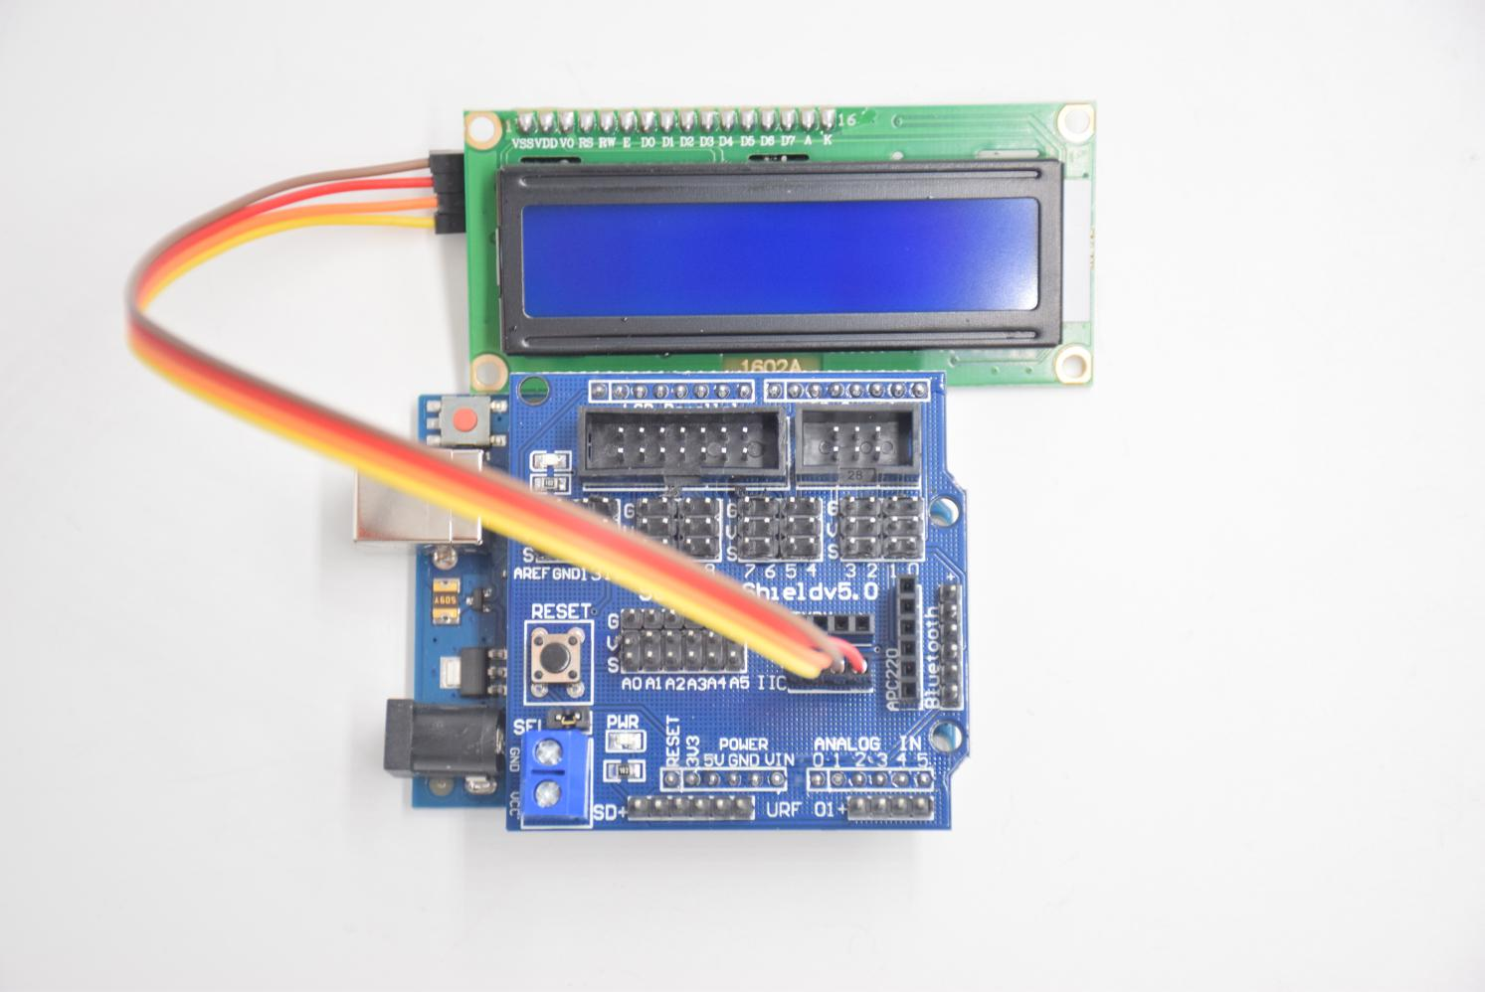

**SCL -- SCL**

**SDA -- SDA**

**VCC -- +**

**GND -- -**

**Test Code:**

**#include <Wire.h>**

**#include <LiquidCrystal_I2C.h>**

**LiquidCrystal_I2C lcd (0x27,16,2); // set the LCD address to 0x27 for a16 chars and 2 line display**

**void setup ()**

**{**

**lcd.init (); // initialize the lcd**

**lcd.init (); // Print a message to the LCD.**

**lcd.backlight ();**

**lcd.setCursor (3,0);**

**lcd.print ("Hello, world!"); // LED print hello, world!**

**lcd.setCursor (2,1);**

**lcd.print ("zhinengchuanke"); // LED print keyestudio!**

**}**

**void loop ()**

**{**

**}**

**Test Result:**

After connection and uploading sample code, the first line on LCD prints "Hello, world!", second line prints "zhinengchuanke", with a potentiometer to adjust LCD backlight.